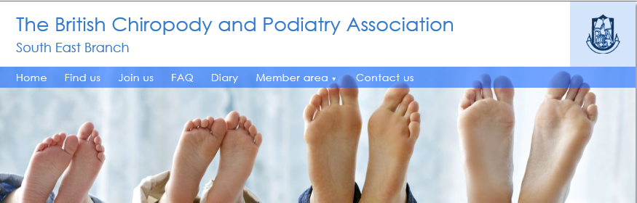
General Data Protection Regulation

This notice is designed to clearly inform you on what data we obtain from you; how we store it; how it may be processed; by whom it may be processed; how you may obtain a copy of the data we hold on you and when the data will be destroyed.
The data we obtain from you:
Public details: Including your name, e-mail address Surgery details including address, telephone number, professional qualifications.
Private details: Including your home address, telephone number, mobile number.
CPD details: If you include it electronic details of the CPDs you store.
Admin details: Including application dates, renewal dates, agreement to rules and viewing of GDPR notice, HCPC numbers.
How do we obtain the data?
Public details, private details and CPD is all managed by yourself when you apply to join the BCPA South East Branch. Admin Details are produced and managed by the branch administrator who is chosen at the branch Annual General Meeting and various system algorithms in support of the administration process.
Why is the data obtained?
The branch has over 100 members and so the data is used to support the administration.
Names and contact details are presented on the public page so that members and the public can identify and contact the individual members.
E-mails and addresses are used to contact members regarding membership renewal, meetings, information, newsletters, grades of membership i.e. FHP, Pod etc.
Who has access to the data?
On the public pages members of the public and members.
Members of the branch supporting the website and administrative roles such as the treasurer and secretary.
The system support and web developer PythonOnline.
How is the data stored?
Data is transferred between browsers and our web server via SSL, the standard security technology (https protocol) for establishing encrypted connections. The data is stored in a modern database.
As we hold data on members electronically, the branch is registered with the Information Commissioners Office (ICO)
How is my data processed?
Your data is processed purely in terms of holding and maintaining members' information, administration and contact details in support of the function of the BCPA South East Branch.
Your data is not used for promotional or marketing purposes.
Your data will not be passed onto any third parties.
How long is your data stored?
All the time that you are an active member and two years' past.
After you have left the branch for two years your data will be deleted.
How can I access my data?
Through the password secured members' area and in the "my account" option on the BCPA South East Branch website http://www.bcpasoutheastchiropody.co.uk.

